PROGRAM
import cv2

img = cv2.imread("rotation_image.png")

if img is None:
print("Image not found! Check the image name.")
else:
rotated = cv2.rotate(img, cv2.ROTATE_180)

cv2.imshow("Original Image", img)
cv2.imshow("Rotated Image - 180 Degrees", rotated)

cv2.imwrite("rotated_180.png", rotated)

cv2.waitKey(0)
cv2.destroyAllWindows()

print("180-degree rotated image saved successfully!")

OUTPUT
The original mountain-lake image and its 180-degree rotated version are displayed. The rotated image appears upside down and is saved as rotated_180.png.

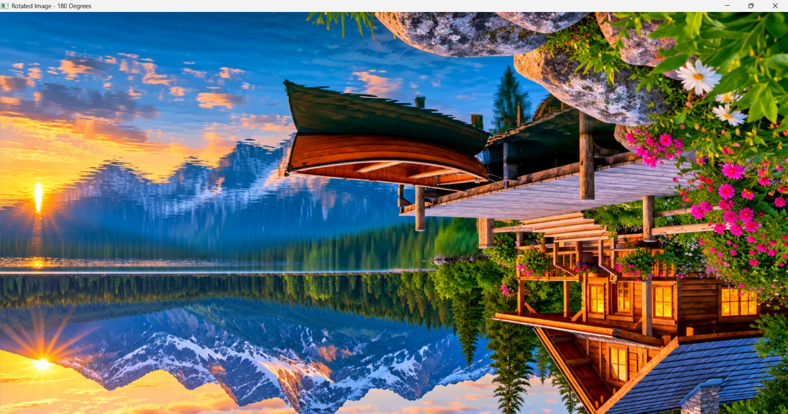

RESULT
Thus, the given image was successfully rotated by 180 degrees clockwise using Python and OpenCV.

